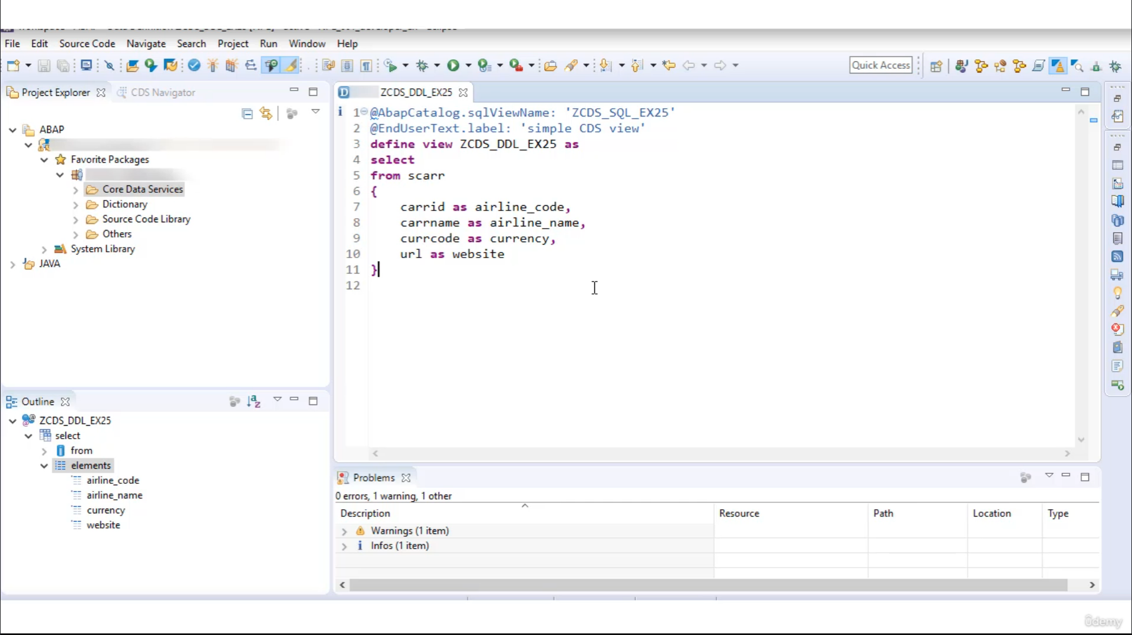

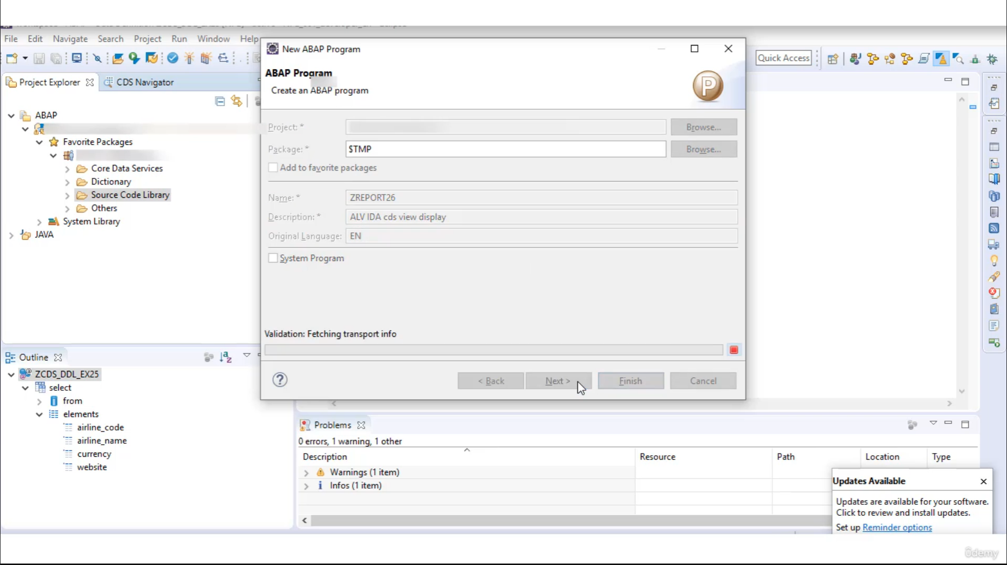

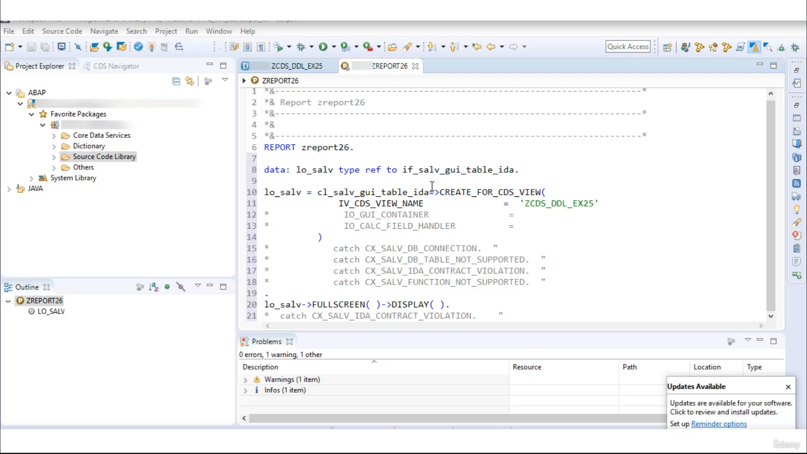

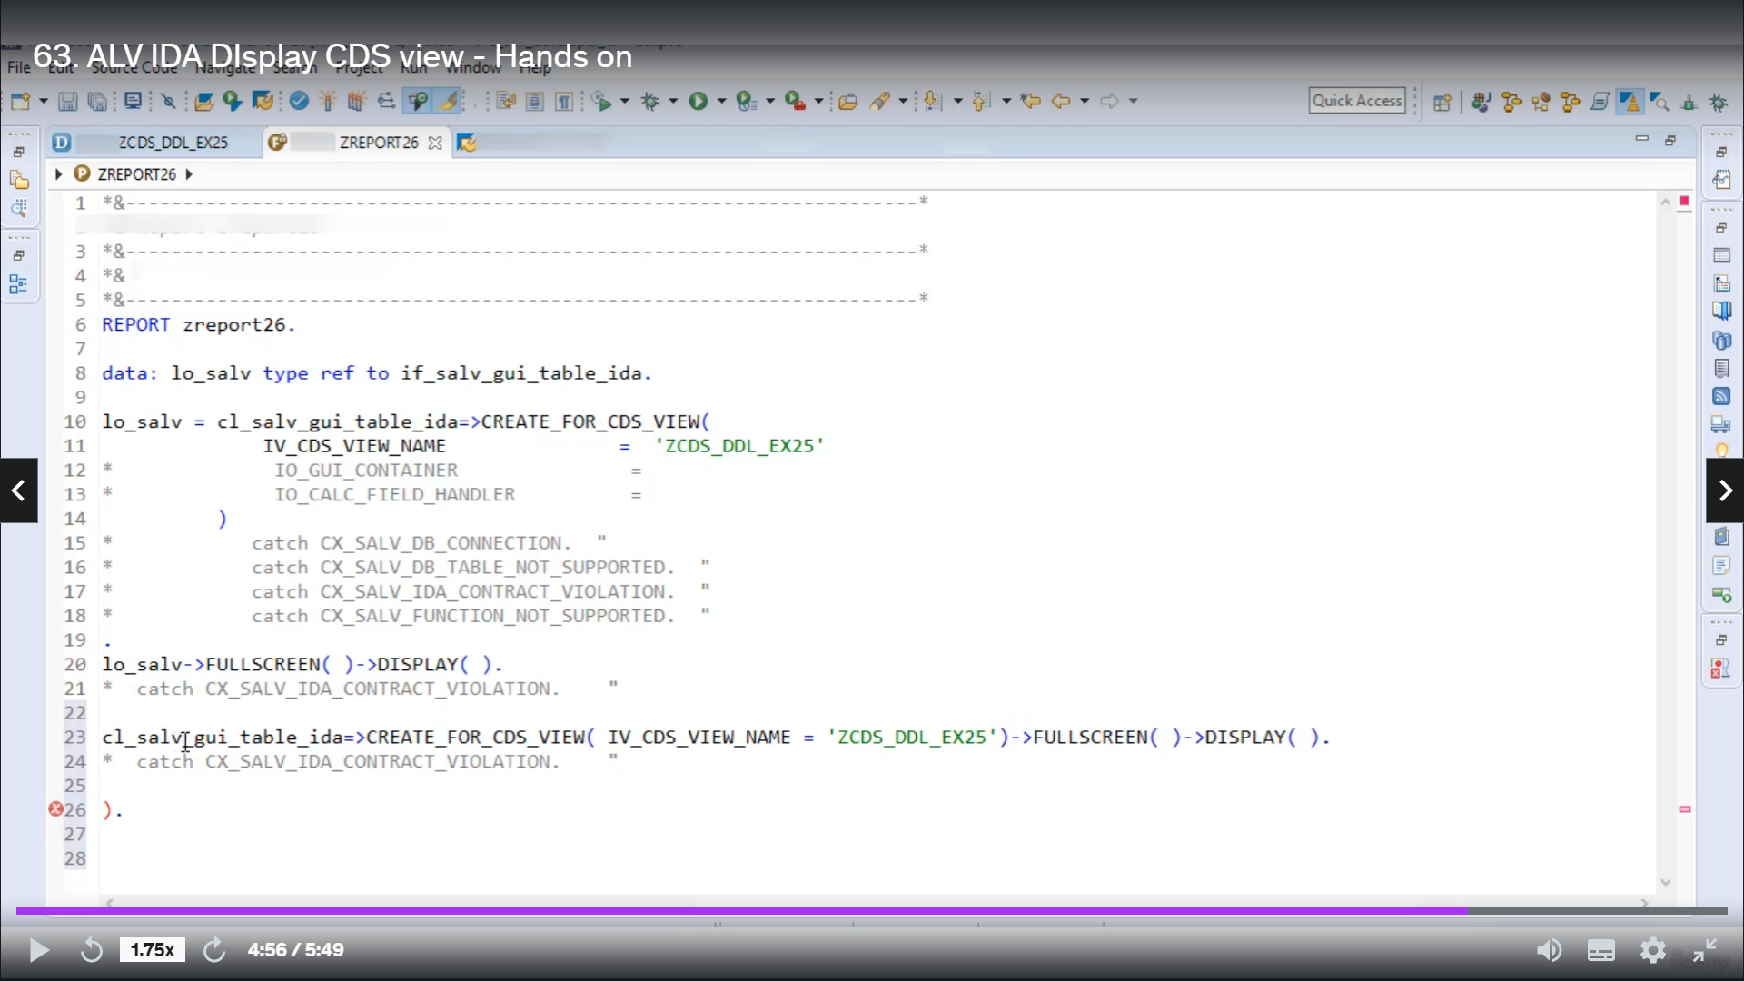

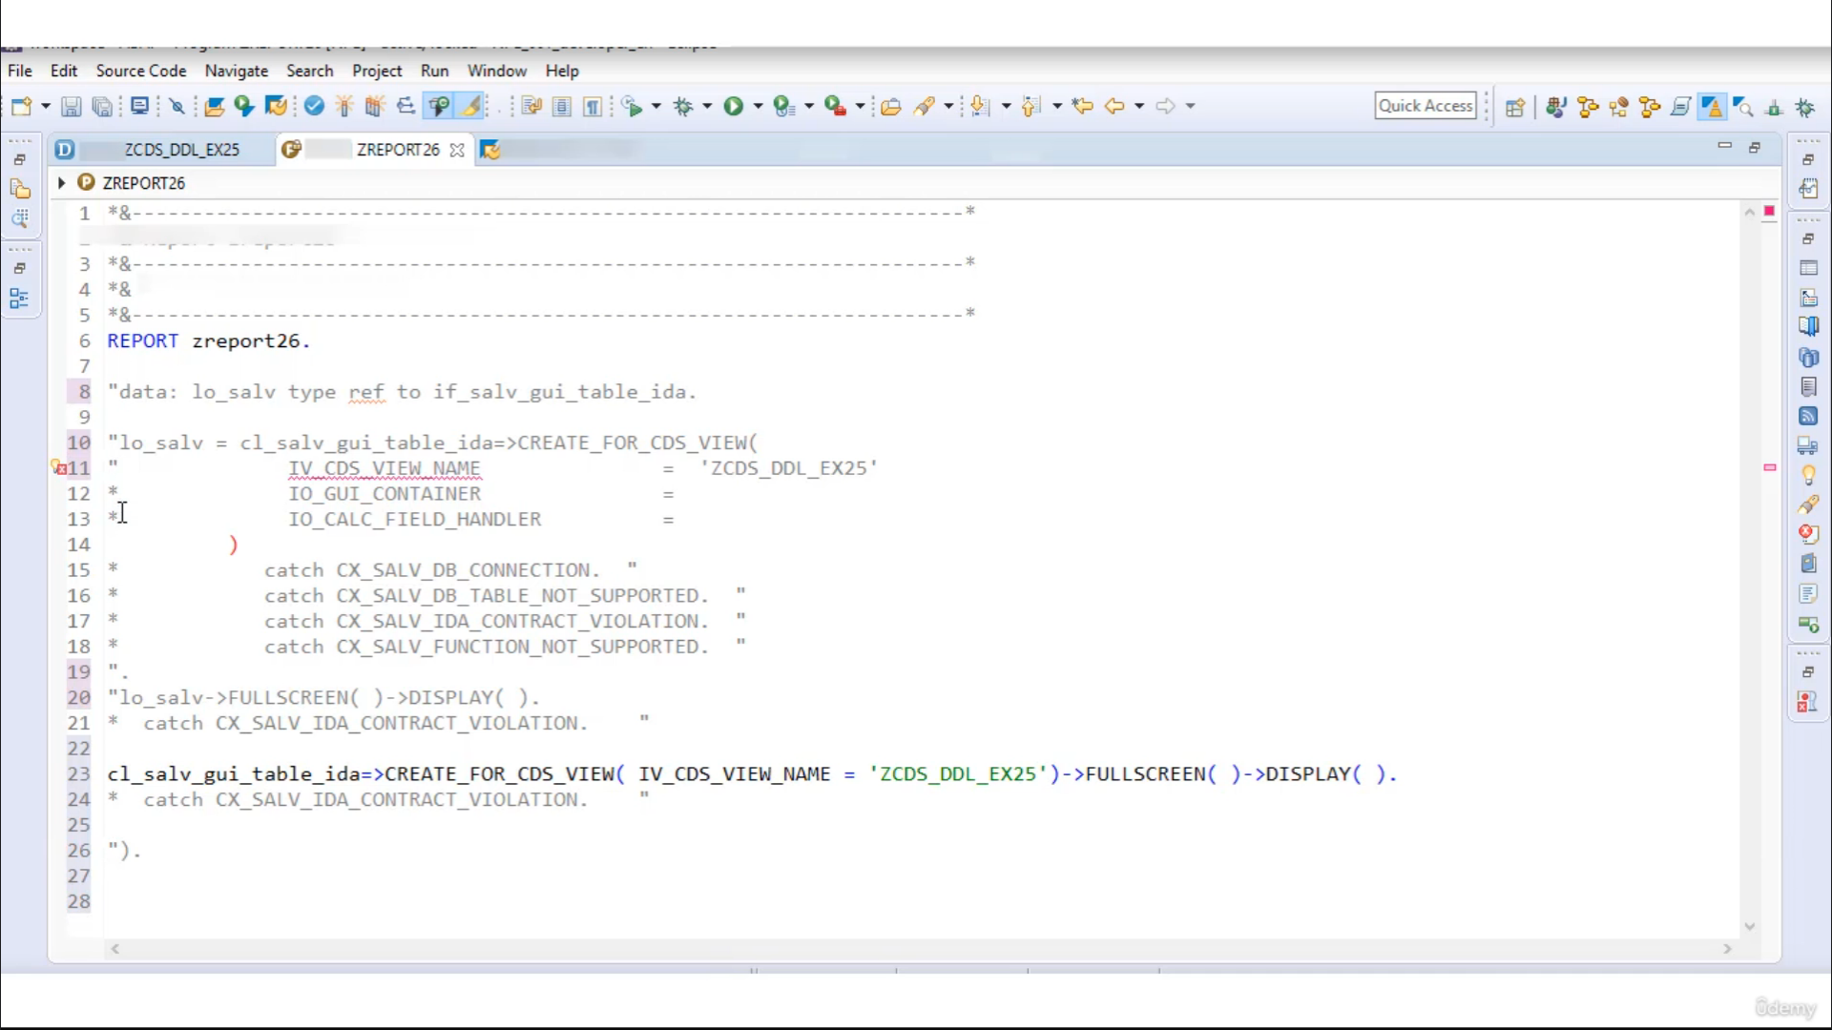

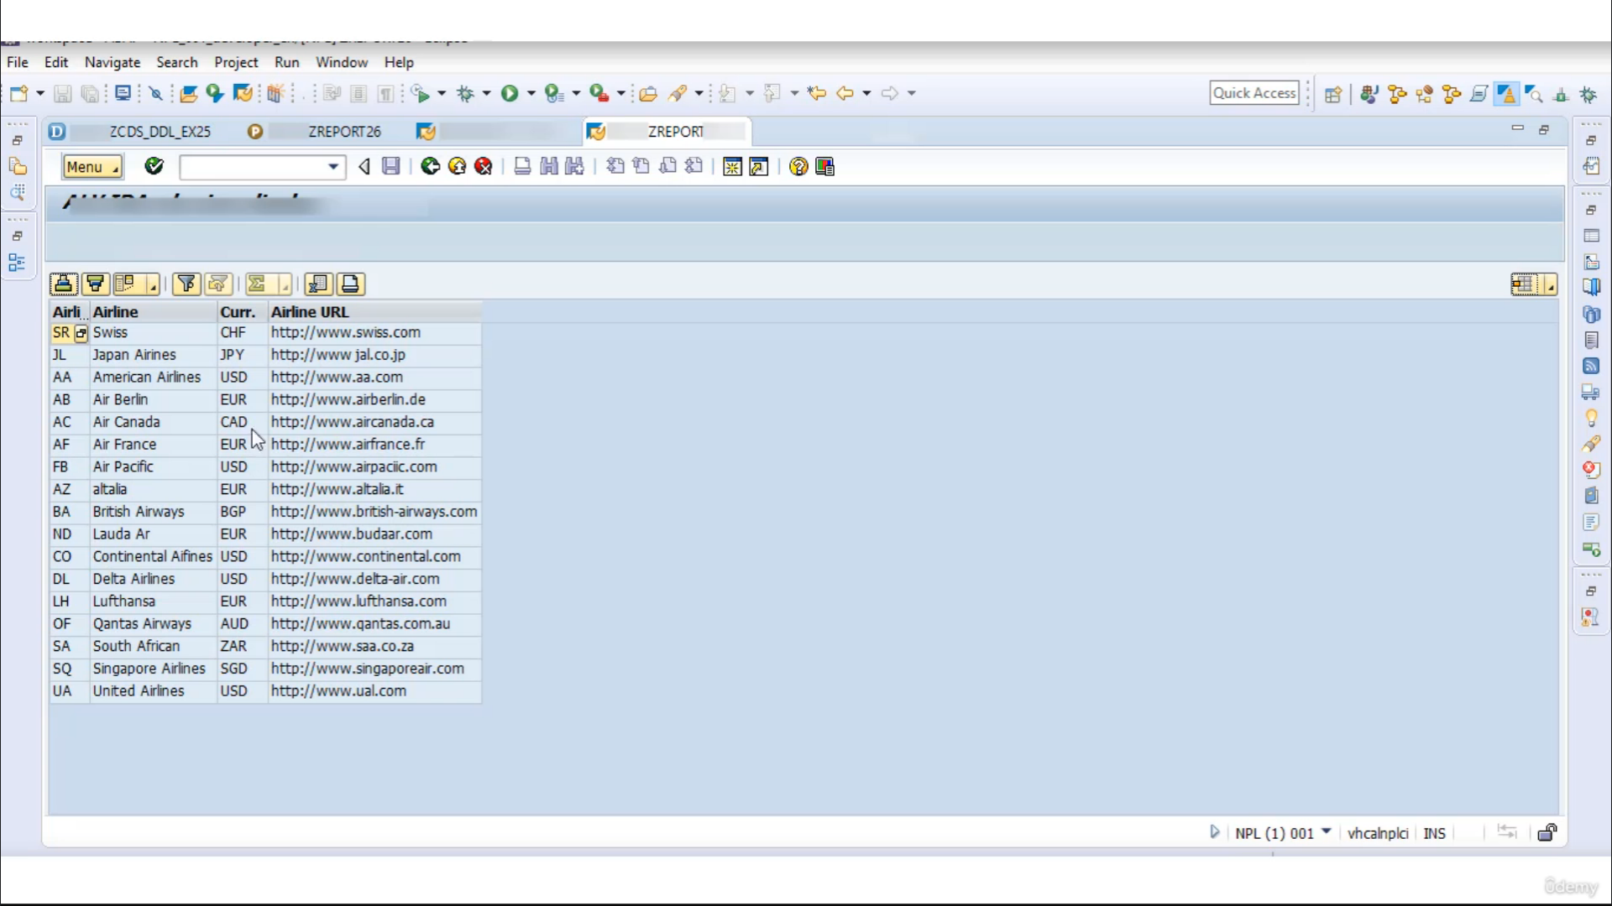

Now, let's create one them seriously, then we will create one program and we will display the content

in a website series using a video.

So let's start.

Good name as Jerseylicious example.

Twenty five and description is simple, yes, we.

I will use to defined view.

OK, now let's say we want to read content from Table Second and the filter down to this piece, Garatti

has

Earling called then Ghanim as headline name then.

Currency, Cordell's

currency, and the last 20 years you are in.

As Web site.

OK, there is no evidence so we can do this good.

Now let's see the output of our returns, EDV.

So here we go.

That means I was blessed with a working fine.

No, I will create one report program.

Beginning

to put 26, I will do description as Elvie idea CDU display.

Now, you first, I will create one reference variable that refers to interface is tell me, do a table

idea, then I will call metre in glass SLV Geula table idea.

And that static method is

created for seniors.

Now here you are to pass through this volume of a creative solution.

Name is Jerseylicious.

Did example identify.

Then you have to give a call to Mr. Fullscreen.

And thing to meto display.

And that's it.

So there is no error, so we can activate this code.

And literally.

And here they are put off of the.

So this is how you can use a little bit idea to display contenting above studious view.

You also can this undercoating single line first we are to write Glazner.

Plus, I saved you a table, I did then you have to Google to metal grid fastidiosa you then you are

the boss.

The name of it is so you that you want to display the variable I, Vesalius, you name,

then you have to call me to fullscreen.

Dean Bumm display.

So this is all you can ride this entire code into a single lane, so to test, I will comment on this

so-called.

So now let's activate.

OK, good.

So it is our put.

So this is all you can break, enter code into a single lane, and this kind of treatment is called

Mater Cheney.

That's it for now.

Have a nice day.